SMARTBRIDGE – IOT EXTERNSHIP

|  |  |
| --- | --- |
| **Name: Rohit Surya** | **University: VIT Chennai** |
| **Reg No: 20BEC1159** | **Assignment 3** |

# TASK:

In Wokwi, add a LED and switch it ON and OFF from Node-Red.

# LINK:

https://wokwi.com/projects/366877247067390977

# CIRCUIT DIAGRAM:

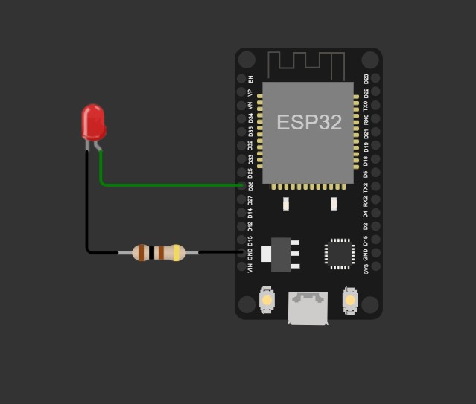

**CODE:**

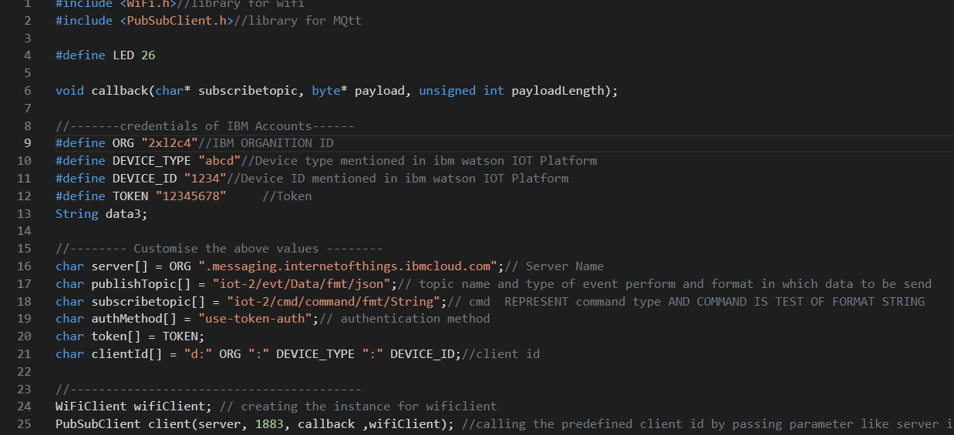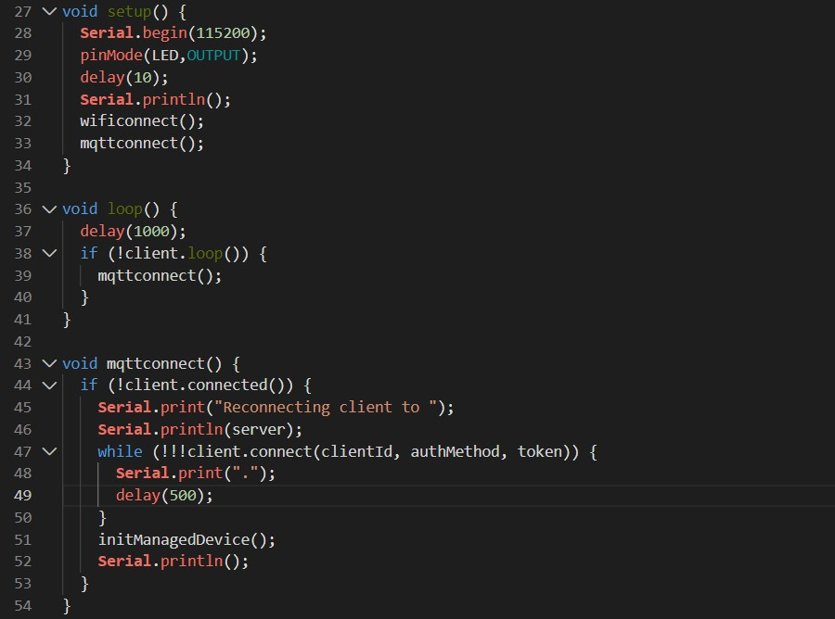

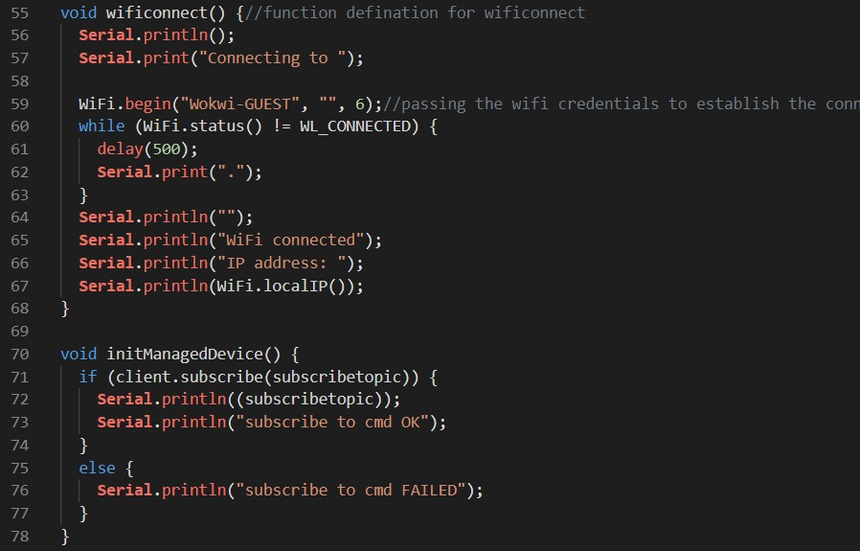

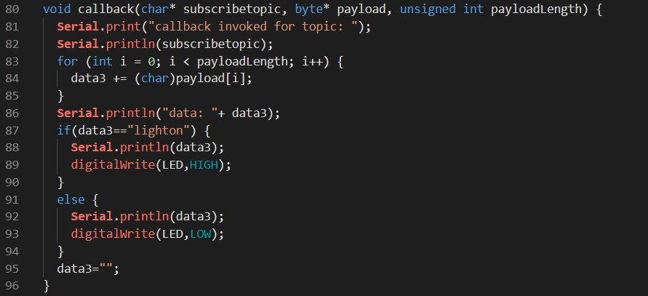

# NODE RED FLOW DIAGRAM:

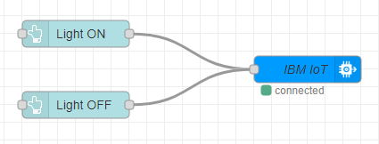

**NODE PROPERTIES:**

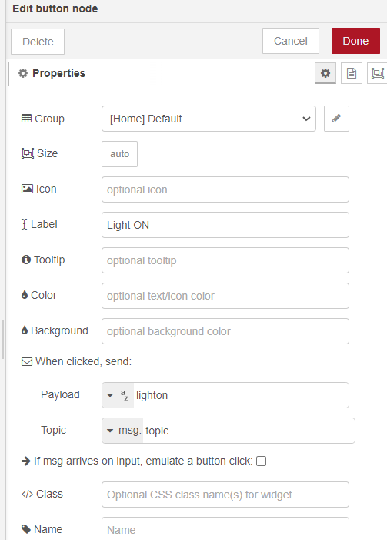

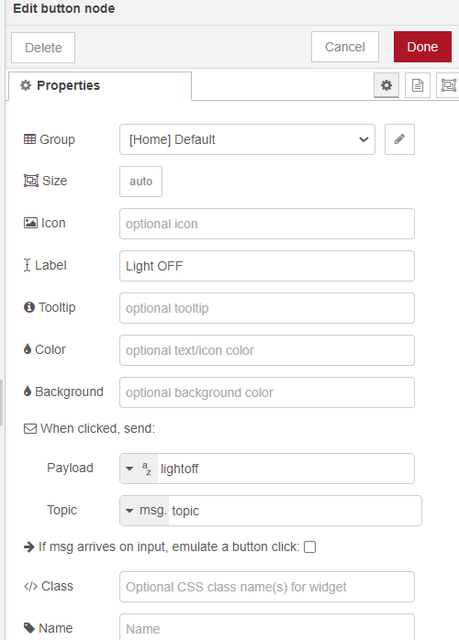

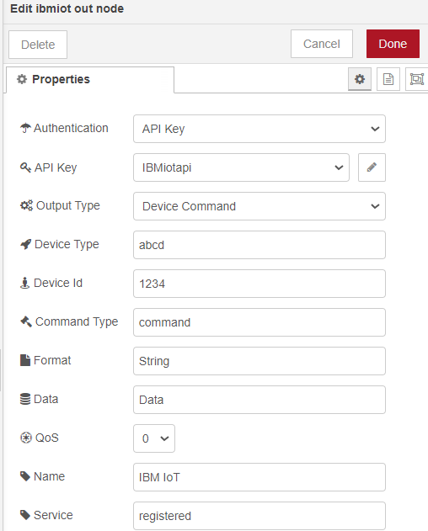

# NODE RED DASHBOARD:

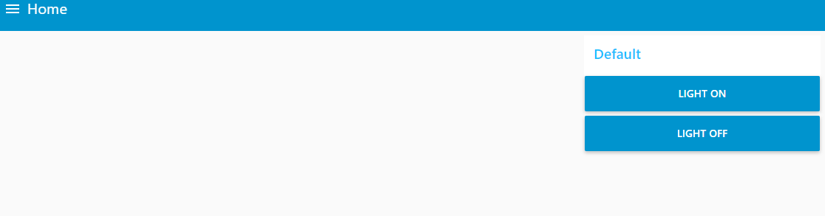

**OUTPUT:**

When “LIGHT ON” button is clicked on the dashboard-

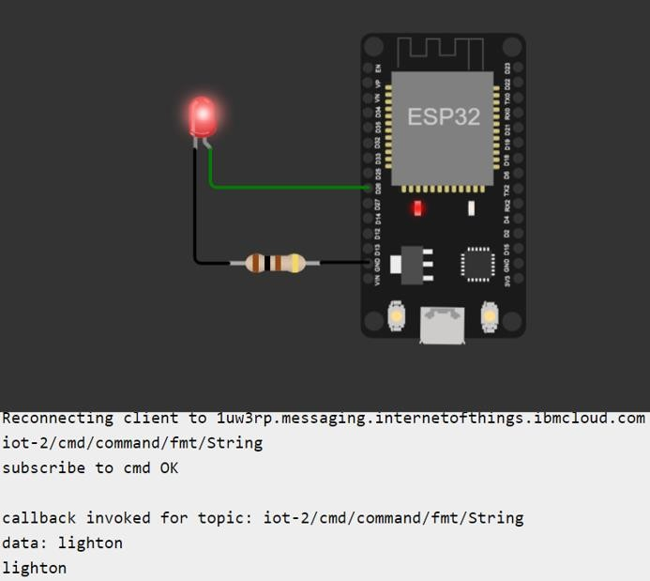

When “LIGHT OFF” button is clicked on the dashboard-

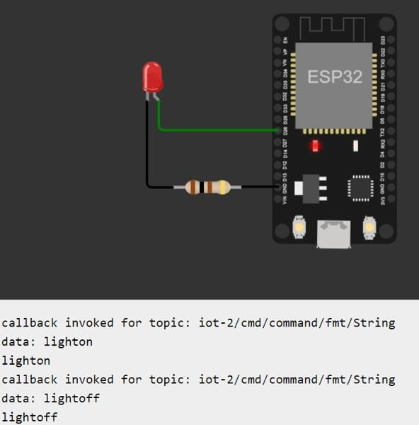

Serial Monitor Output-

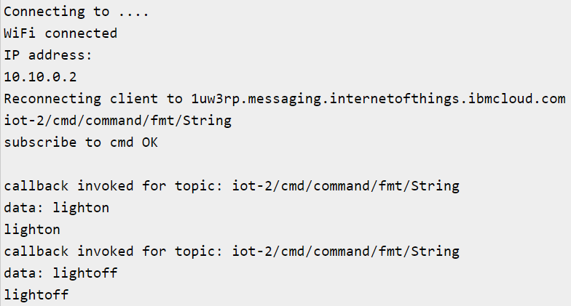

# RESULT:

The given task was implemented successfully.